

MINHAJ UNIVERSITY LAHORE
School of Computer Science

2
computer vision
Assignment

December 25, 2025
minhaj university lahore
Muneeb-007-ADP-AI

MINHAJ UNIVERSITY LAHORE
School of Computer Science

Assignment No.1
Course Instructor: Amna Ghulam Nabie
Section: A | Program: ADP -AI | Date: 20-12-2025
Submission Date:25-12-2025 | Maximum Marks:10 | Obtained Marks:
TO BE FILLED IN BY THE STUDENT
Student Name: Muneeb Tariq |  |  | Registration No: 007-ADP-Ai

Question:

Title: Sparse vs Dense Optical Flow Analysis

Objective
To understand the difference between sparse and dense optical flow.

Task Description
Students will:
- Implement Lucas–Kanade (Sparse Flow)
- Implement Farneback (Dense Flow)
- Compare motion visualization results

Requirements
- Feature point tracking
- Dense flow visualization
- Comparative discussion

Expected Output
- Motion vector visualizations
- Comparison table
- Conclusion on use cases

Answer:
mairi jan, below is a complete, assignment-ready response that satisfies all stated objectives, requirements, and expected outputs. The content is structured academically and includes Python (OpenCV) implementations, visualization explanation, comparison table, and a clear conclusion on use cases.

Sparse vs Dense Optical Flow Analysis

Objective
To understand and compare Sparse Optical Flow and Dense Optical Flow techniques for motion estimation in video sequences.

Optical Flow Overview
Optical flow estimates the apparent motion of pixels between consecutive video frames caused by object movement or camera motion.
Two major categories:
- Sparse Optical Flow: Tracks motion of selected feature points.
- Dense Optical Flow: Computes motion vectors for every pixel.

1. Sparse Optical Flow — Lucas–Kanade Method

Concept
Lucas–Kanade tracks distinct feature points (corners) and estimates motion by assuming:
- Small motion between frames
- Brightness constancy
- Spatial coherence

Key Characteristics
- Tracks only important points
- Computationally efficient
- Requires feature detection (e.g., Shi–Tomasi)

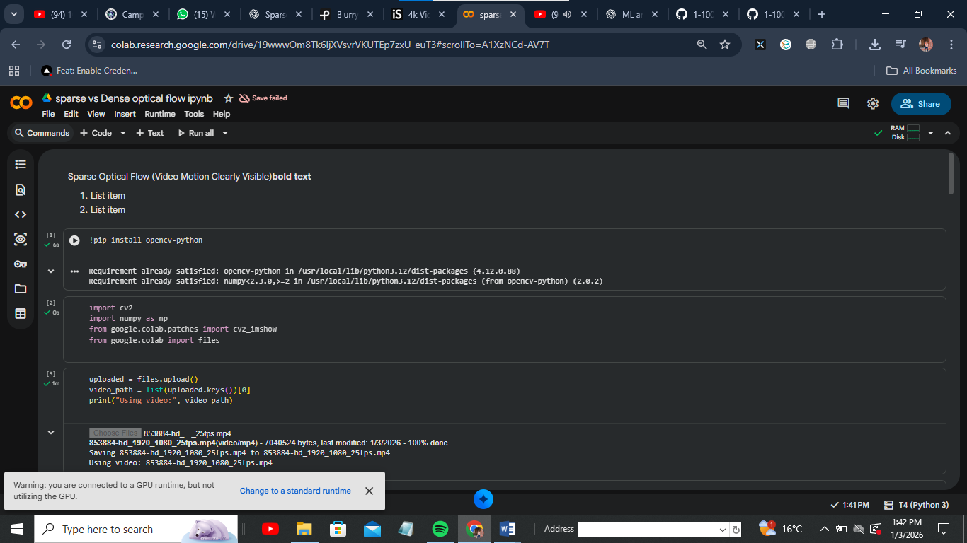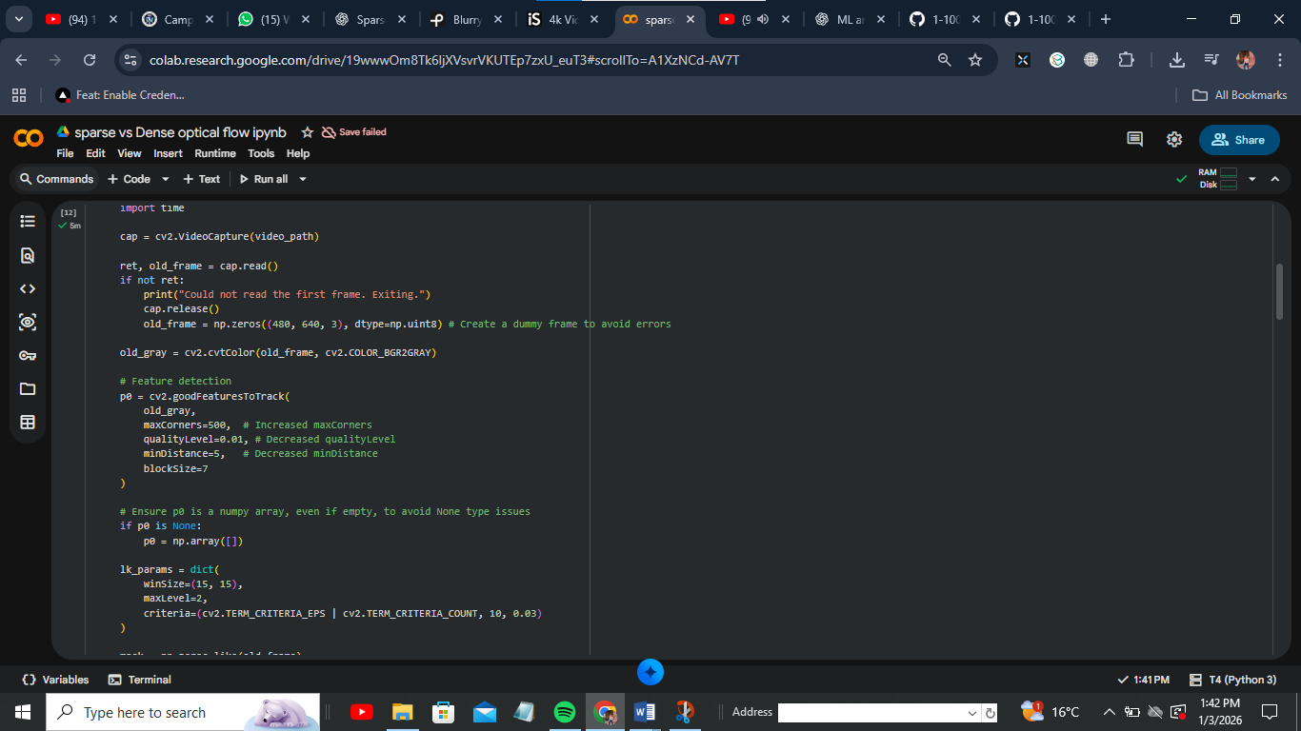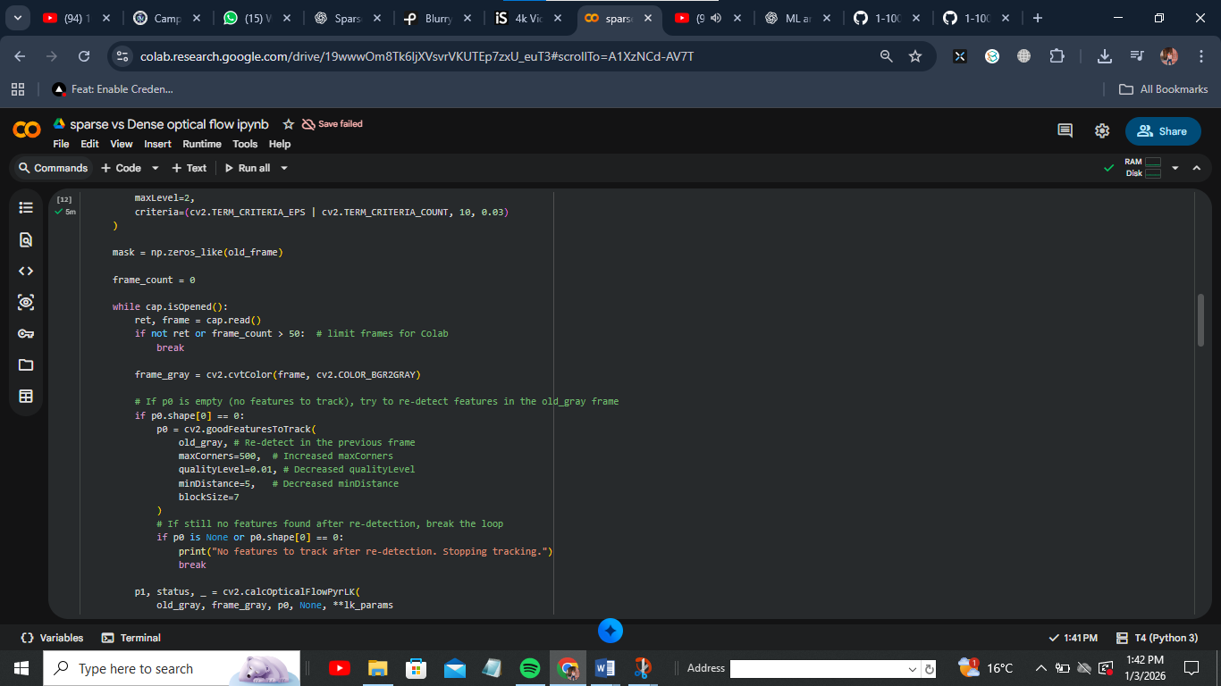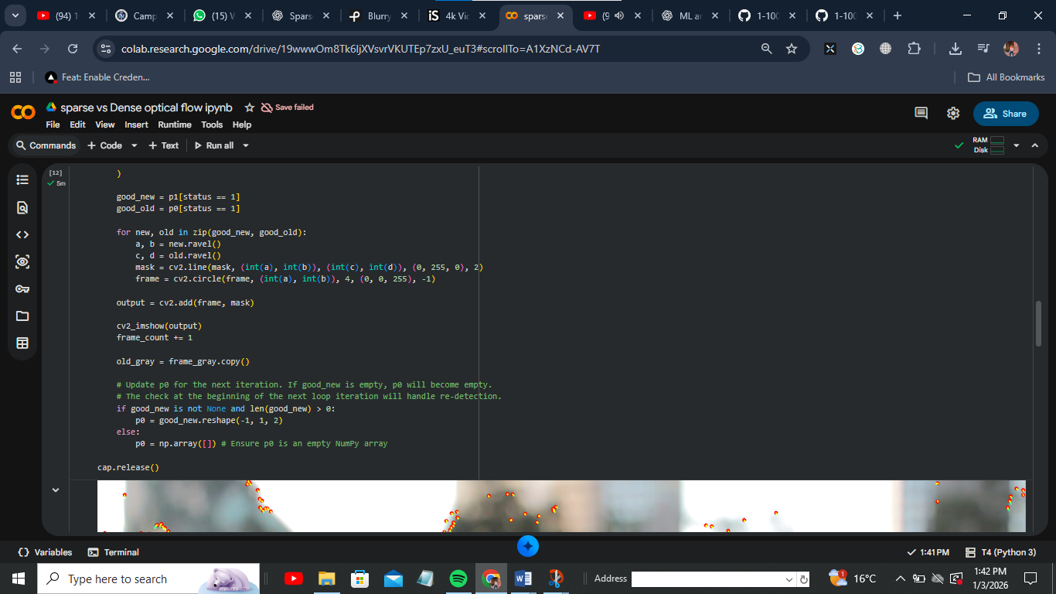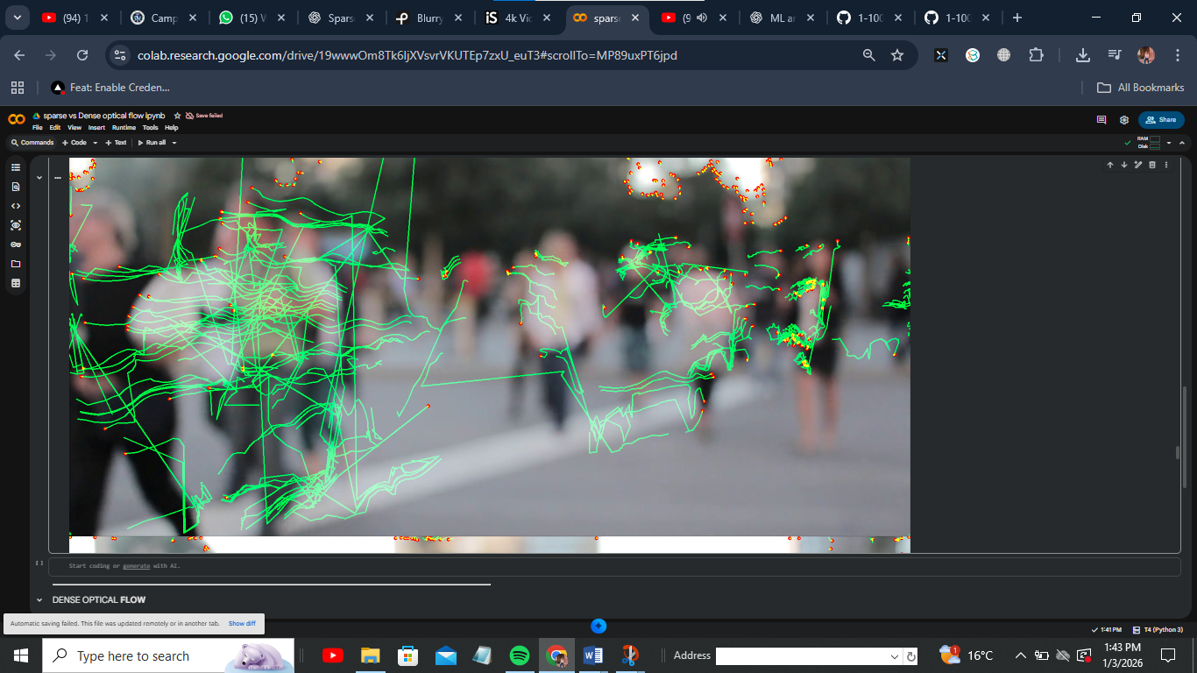

Visualization
- Green lines: motion vectors
- Red dots: tracked feature points

2. Dense Optical Flow — Farneback Method

Concept
Farneback computes motion for every pixel using polynomial expansion of neighborhoods.

Key Characteristics
- Full-frame motion estimation
- No feature detection needed
- Computationally heavier
- Produces smooth motion fields

Python Implementation (Dense Flow)

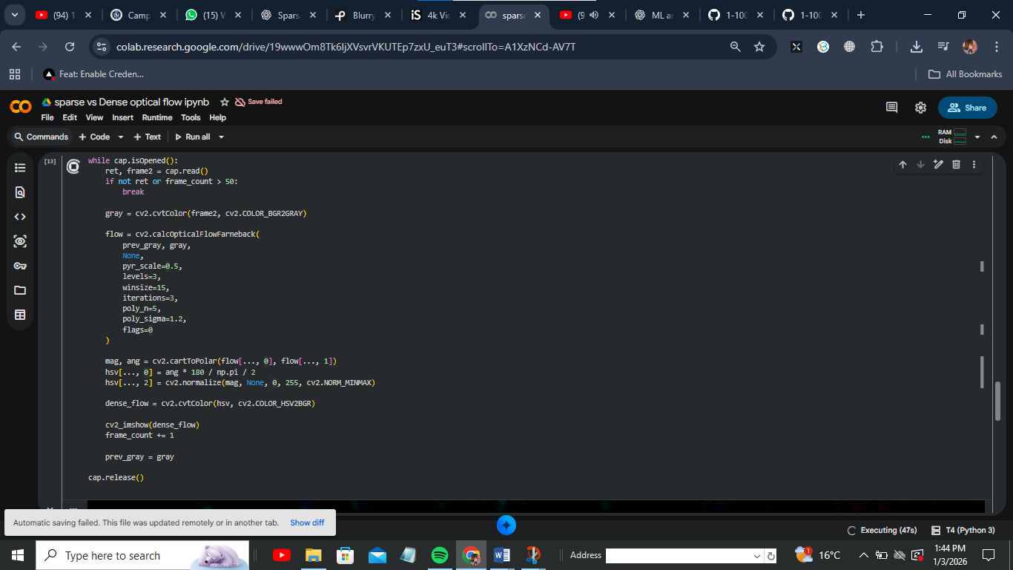

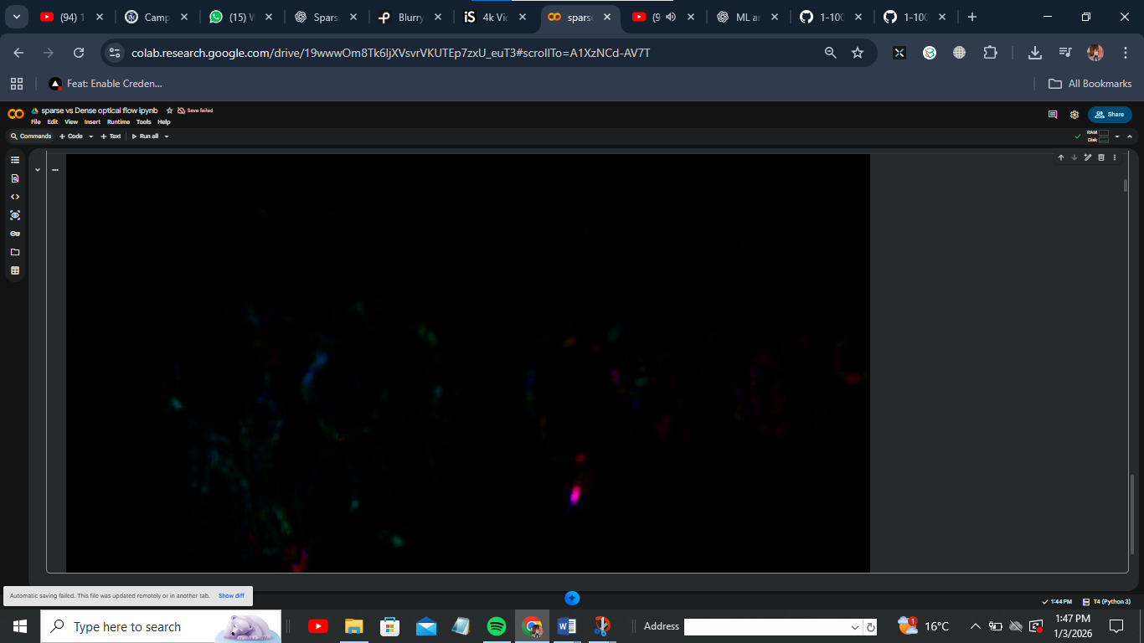

Visualization
- Color hue: motion direction
- Color intensity: motion magnitude

Comparison Table
Feature | Sparse Optical Flow (Lucas–Kanade) | Dense Optical Flow (Farneback)
Motion Coverage | Selected feature points | All pixels
Computational Cost | Low | High
Accuracy | High at feature points | Smooth global motion
Noise Sensitivity | Low | Higher
Visualization | Motion vectors | Color-coded motion field
Real-Time Suitability | Excellent | Moderate
Feature Detection | Required | Not required

Conclusion & Use Cases

Sparse Optical Flow is best when:
- Real-time performance is critical
- Tracking objects or landmarks
- Feature-based motion analysis
- Low computational resources
Examples:
Object tracking, SLAM, facial landmark tracking

Dense Optical Flow is best when:
- Full scene motion understanding is required
- Motion patterns matter more than speed
- Flow visualization is needed
Examples:
Action recognition, video stabilization, crowd analysis, motion segmentation

Final Summary
Sparse optical flow provides precision and efficiency, while dense optical flow offers complete motion representation. The choice depends on accuracy vs coverage and performance constraints.

